English Conversation – For or Against

Choose one of the following issues and state whether you are “for” or “against” it, giving your reasons. If you are neither “for “nor “against”, then we say that you are “on the fence”.

FOR | AGAINST | ON THE FENCE
I’m for it because …. | I’m against it because …. | I don’t have an opinion on the matter.
I’m in favor of it because …. | I’m opposed to it because …. | It doesn’t concern me.
I’m totally in favor of it because .... | I’m totally opposed to it because …. | I don’t really care.
I agree because .... | I don’t agree because ... | It doesn’t matter to me.

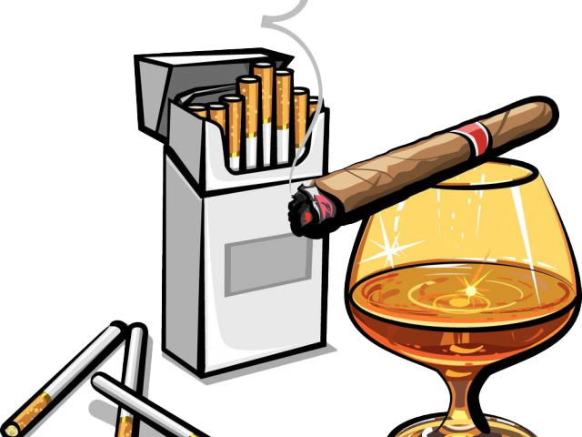
- Smoking in open public places
- Smoking in closed public places
- Drinking in public places
- Free high school education for all
- High taxes on tobacco
- High taxes on alcohol
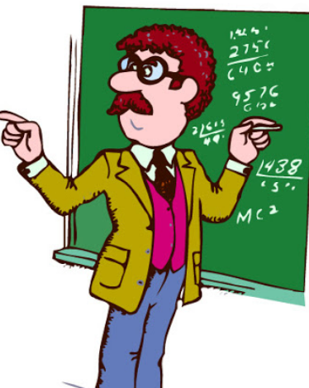
- High taxes on imports
- Small classes in schools
- High salaries for teachers
- Transparency in political activities
- Mandatory military service for men
- Mandatory military service for women
- Free homes for the homeless
- Free medicine for all

- Free public transportation for all
- Raising the drinking age to 21 (like in the USA)
- Raising the driving age to 21
- Lowering the voting age to 15
- Lowering the smoking age to 15
- Free parking in the city center

